**PROJECT NAME – ONLINE HOTEL RESERVATION**

Part done - Admin part (not all): Adding, Updating, Deleting hotels and viewing customer details.

1. Login screen.

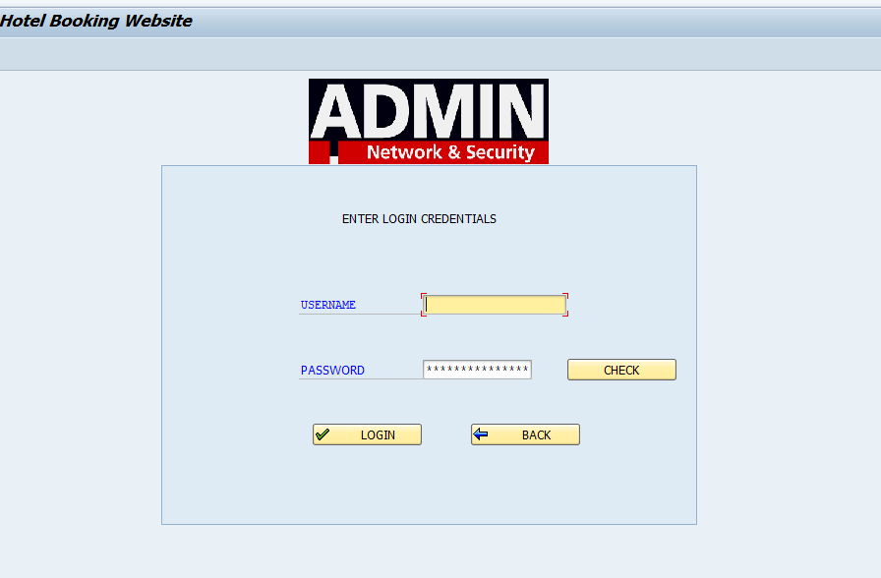

1. If incorrect password / username is entered , the following occurs.

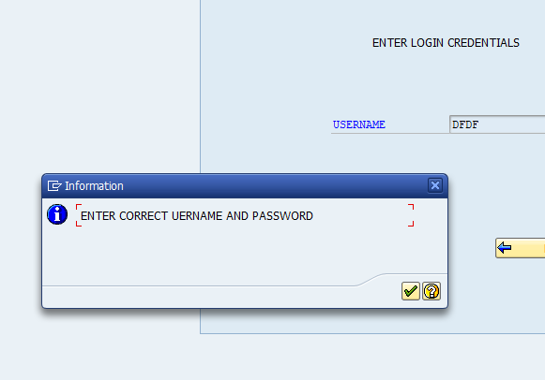

1. When check pushbutton is clicked, the hidden password can be seen.

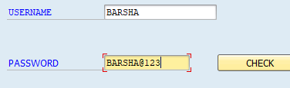

1. Main screen.
2. This is how the main screen appears initially.

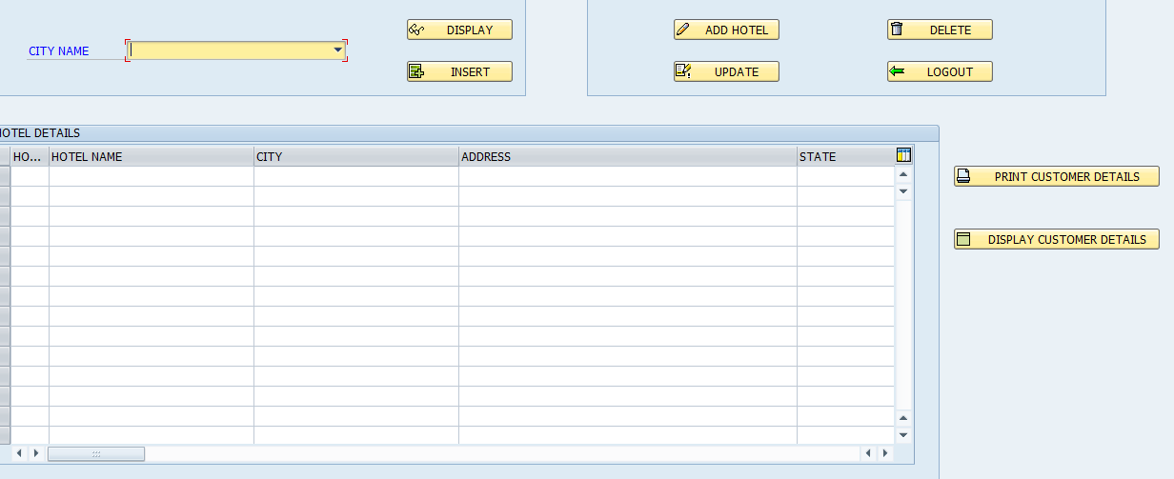

1. When a certain city is selected, all the hotels in that city are displayed and a new line is added when ‘insert’ pusbutton is clicked

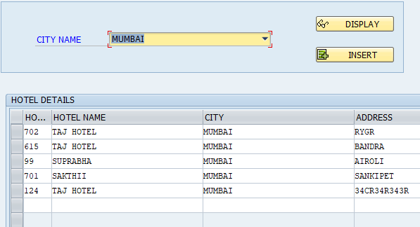

1. The “ADD HOTEL” “UPDATE” “DELETE” “LOGOUT”

Performs addition of hotel , updation/modification of hotel ,

Deletion of any selected hotel and logging out of the screen respectively.

1. The program summons an ALV form containing details of customer when ‘DISPLAY CUSTOMER DETAILS’ is clicked.

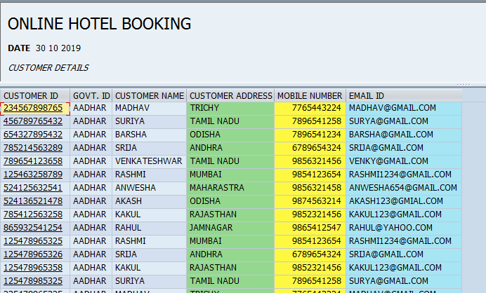

1. If the print out of the customer is required , we can click on “print customer details” to get the pdf.

